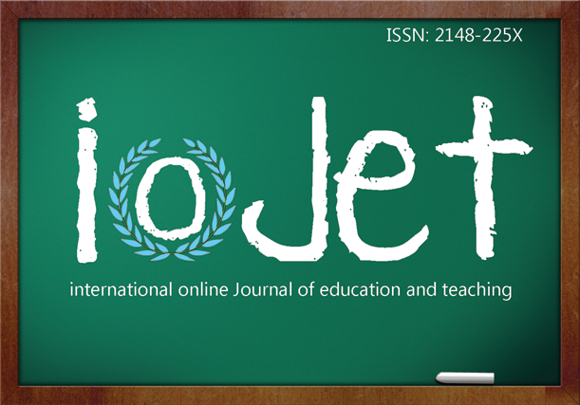 | Buyuktas Kara, M., Van Steendam, E., Rijlaarsdam, G., Kuru, H. (submitted). The effect of two modes of strategy instruction: Modeling vs. Presentational. International Online Journal of Education and Teaching (IOJET), X(X). p-p. Annotated link of the article.

THE EFFECT OF TWO MODES OF INSTRUCTION: MODELING VS. PRESENTATIONAL
Mujgan Buyuktas Kara
Research Institute of Child Development and Education. University of Amsterdam
mujganbuyuktaskara@gmail.com
Gert Rijlaarsdam
University of Antwerp, Belgium
g.c.w.rijlaarsdam@uva.nl
Elke Van Steendam
KULeuven, Belgium
elke.vansteendam@arts.kuleuven.be
Huseyin Kuru
Sapienza University of Rome, Italy
kuru.1515904@studenti.uniroma1.it

Department of Child Development and Education, PO Box 15776, 1001 NG Amsterdam
Mujgan Buyuktas Kara holds a BA and MA in English Language and Literature. She is currently working on her PhD at University of Amsterdam. Her research interests include writing instruction and writing processes in English as a foreign language (EFL).
Elke Van Steendam is an assistant professor at KU Leuven and University of Antwerp, Belgium. Her research interests include writing instruction and assessment, writing processes in a first (L1) and second/foreign language (L2/FL), collaborative writing and revision.
Gert Rijlaarsdam is a professor and an investigator of the Research Lab of Language, Literature & Arts Education at the University of Amsterdam, a member of the AnhubLab at University of Antwerp and a visiting professor at Umea University, Sweden.
Huseyin Kuru holds a BA in Statistics from Istanbul Commerce University and MBA in Advanced Economics from Sapienza University of Rome. He worked as a marketing manager in Rome and is currently working as a digital marketing specialist in Barcelona.
Copyright by Informascope. Material published and so copyrighted may not be published elsewhere without the written permission of IOJET.

