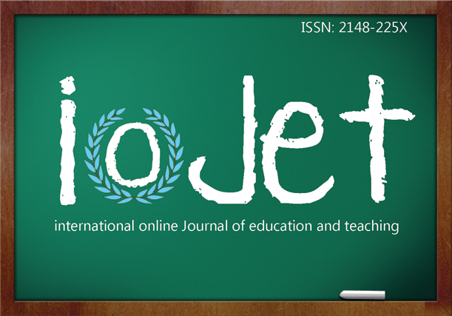 | Iglesias, M. (2016). Language travel supply: the language learning component. International Online Journal of Education and Teaching (IOJET), X(X). p-p. Annotated link of the article.

LANGUAGE TRAVEL SUPPLY: THE LANGUAGE LEARNING COMPONENT

Montserrat Iglesias
EUHT CETT-UB, University of Barcelona
Montserrat.iglesias@cett.cat
Av. Can Marcet 36-38, Barcelona 08035, Spain
Biodata(s): Senior Lecturer of English as a Foreign Language and Head of Studies at CETT Language School. My research focuses on oral competence in English for Specific Purposes and on language tourism. Co-author of an elementary English course for catering students

Copyright by Informascope. Material published and so copyrighted may not be published elsewhere without the written permission of IOJET.

